HSM Guidance document
Updated august 3rd 2026

- All of the individual layers and the full HSM maps are: H:\Deepwater Horizon Oil Spill\9 - RESTORE\2 - Gulf Council\Estuary Program\GIS\GIS_Projects\HSM\HSM_2026
- We ran the HSM with the 1883 oyster layer included and excluded - both versions are in this folder
- We also ran the HSM model with the stretch raster categories and then also binned the HSM into categories. They show the model slightly different, but it is just a difference in how the data are portrayed
- The GIS HSM document is also in the HSM_2026 folder and is titled HSM_2026
  - The individual rasters, meaning the individual layers that go into the HSM, are in 2 separate folders in the GIS folder. See below where it says “load all the rasters.” This is here in case you need to rerun the model or reconnect the rasters.
- Note: The suitability scale on the individual variable maps:
  - Low suitability = 1
  - Moderate suitability = 5
  - High suitability = 10

How to run the model
- Open the HSM_2026 file: H:\Deepwater Horizon Oil Spill\9 - RESTORE\2 - Gulf Council\Estuary Program\GIS\GIS_Projects\HSM\HSM_2026
- Go to analysis suitability modeler Name the model and the output and put it as weighted by percent. You can set the suitability scale from 1-1 or 1-10.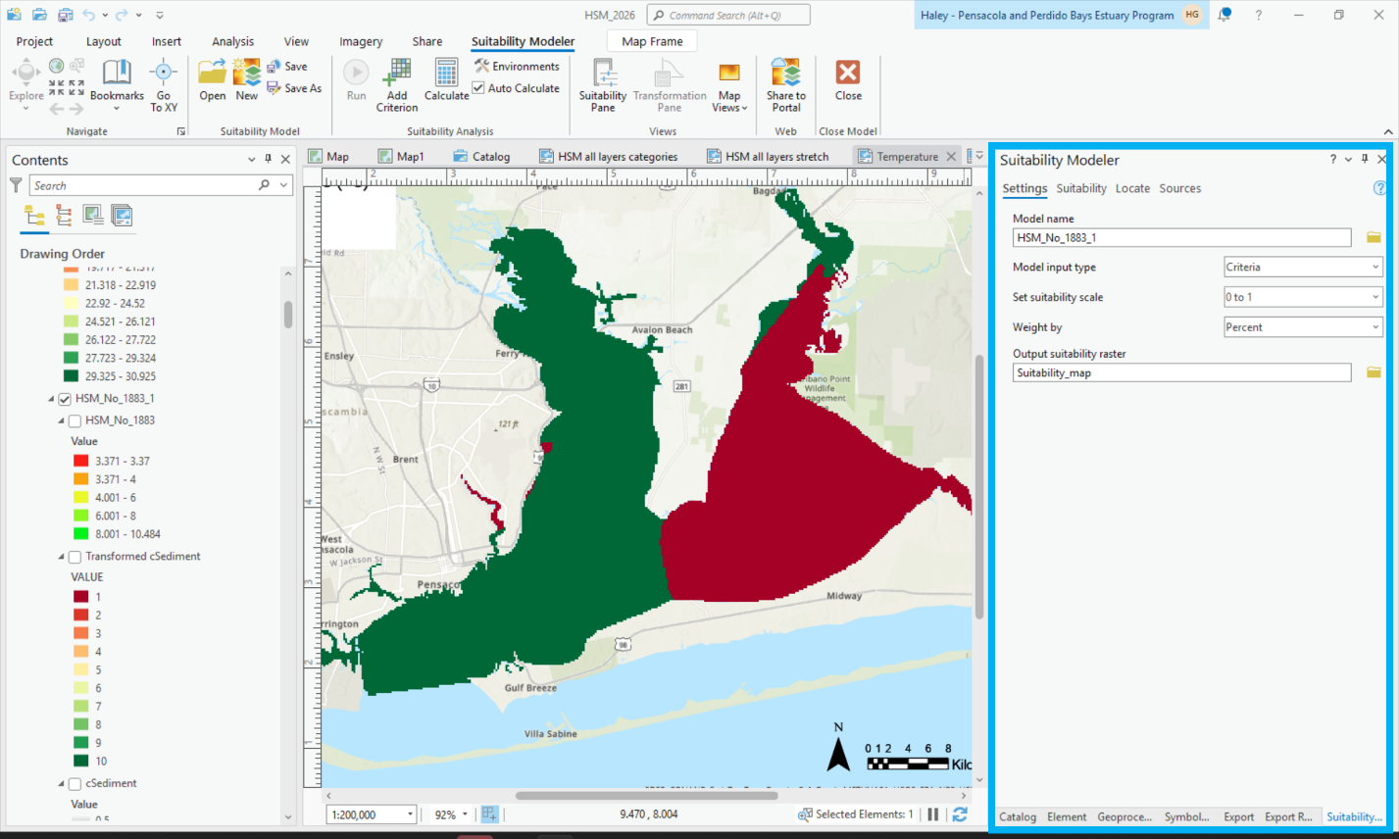
- Click on the Suitability tab and load all the rasters
  - Estuary Program GIS GIS Projects Index HSM - HSM.gbd
    - C1883 (1883 oysters)
    - C1883_Oysters_ProjectRaster (Larval dispersal)
    - C2021 (2021 oysters)
    - cSediment (sediment)
    - Feature_resu2 (Turbidity)
    - Salinity_bottom_Raster (Bottom Salinity)
    - Temp_bottom_Raster (Bottom Temperature)
  - Estuary Program GIS GIS Projects HSM HSM_Updated.gdb
    - DO_Bottom_Cait (Bottom DO)
    - Chla_raster (Chlorophyll a)
- Classify and Transform Variables: For each raster you will need to click on the button on the left right beside the raster to categorize and transform the variable: Click on each button to make the transformation click on Range of Classes click Classify Add methods as Nature Breaks (Jenks) or Manual Interval change number of classes change the labels click okay
  - Unique categories for
    - 1883
    - 2021
  - Continuous function linear
    - Larval dispersal
  - Classifications for each variable
    - Bottom Salinity
      - 16.51-20 = Moderately suitable (5)
      - 20-25 = Highly suitable (10)
      - 25-30.92 = moderately suitable (5)
    - Bottom Temperature
      - 25.56-27.09 = Moderately suitable (5)
      - 27.09-30.66 = Highly suitable (10)
    - Bottom Dissolved Oxygen
      - 0-4 = Low suitability (1)
      - 4-5 = Moderately suitable (5)
      - 5-7 = Highly suitable (10)
    - Chlorophyll a
      - 4.5-16 = Highly suitable (10)
      - 16-46 = Moderately suitable (5)
    - Turbidity
      - 2.06-10 = Highly suitable (10)
      - 10-13.22 = Moderately suitable (5)
    - 1883 Oyster Beds
      - -1 = Low suitability (1)
      - 1 = Moderately suitable (5)
    - 2021 Oyster Beds
      - -1 = Low suitability (1)
      - 1 = Highly suitable (10)
    - Larval dispersal
      - did an inverse linear transformation - same as Laura G
    - sediment
      - 0 = mud = Low suitability (1)
      - 0.25 = muddy sand = Moderately suitable (5)
      - 0.5 = sand = Highly suitable (10)
- Change the percent weighting by double-clicking in the table to change the suitability
 | 1883 Oysters included |  |  |  | No 1883 Weights
Order | Indicator | Weight % |  | Order | Indicator | Weight %
1 | salinity | 18 |  | 1 | salinity | 20
2 | Current oyster | 18 |  | 2 | Current oyster | 20
3 | Larval recruitment | 10 |  | 3 | Larval recruitment | 11
4 | Sediment/substrate | 13 |  | 4 | Sediment/substrate | 14
5 | DO | 15 |  | 5 | DO | 16
6 | Old oysters | 10 |  | 6 | Old oysters | 0
7 | Temp | 6 |  | 7 | Temp | 7
8 | chla | 5 |  | 8 | chla | 6
9 | Turbidity | 5 |  | 9 | Turbidity | 6
 |  | 100 |  |  |  | 100

- Hit run
- In the catalog it shows you the final output of the HSM and it makes it on a scale and you can categorize it if you would want to.

Notes:
- Data for chlorophyll a, bottom dissolved oxygen, bottom salinity, bottom temperature, turbidity were pulled from the water quality data from 2017 to 2023 using May to October data.
- 1883 oysters, larval dispersal, 2021 oysters, and sediment are the same layers that Laura G used in her original HSM.
- If this needs to be recreated the rasters are on various folders on the H drive, but the HSM model saved to my local drive so it will have to be recreated using the steps above.

